ECO 5375-701 Prof. Tom Fomby

Eco and Bus Forecasting Fall 2021

**EXERCISE 3**

**Purpose:** To learn how to import data into R and to use R to produce seasonal plots of time series. For an R program to guide you in completing this exercise, see FPP_2.4_2.5 Seasonal Plots.R. This exercise is due **Thursday, September 9 at 6:30 pm CST. Submit your work on Canvas.**

You are to use the Hawaiian data set **Hawaii.csv** and the “starter” R program **EX3_Hawaiian_Plots.R** to complete the following tasks. Be sure and properly label the y and x axes of your graphs.

(a) Produce a plot of the **original Hawaiian Tourism data** and report it here.

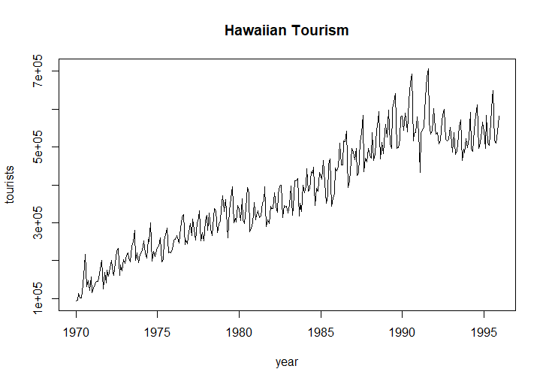

(b) Produce a **Buys-Ballot months-by-year plot** of the Hawaiian Tourism data. Report it here.

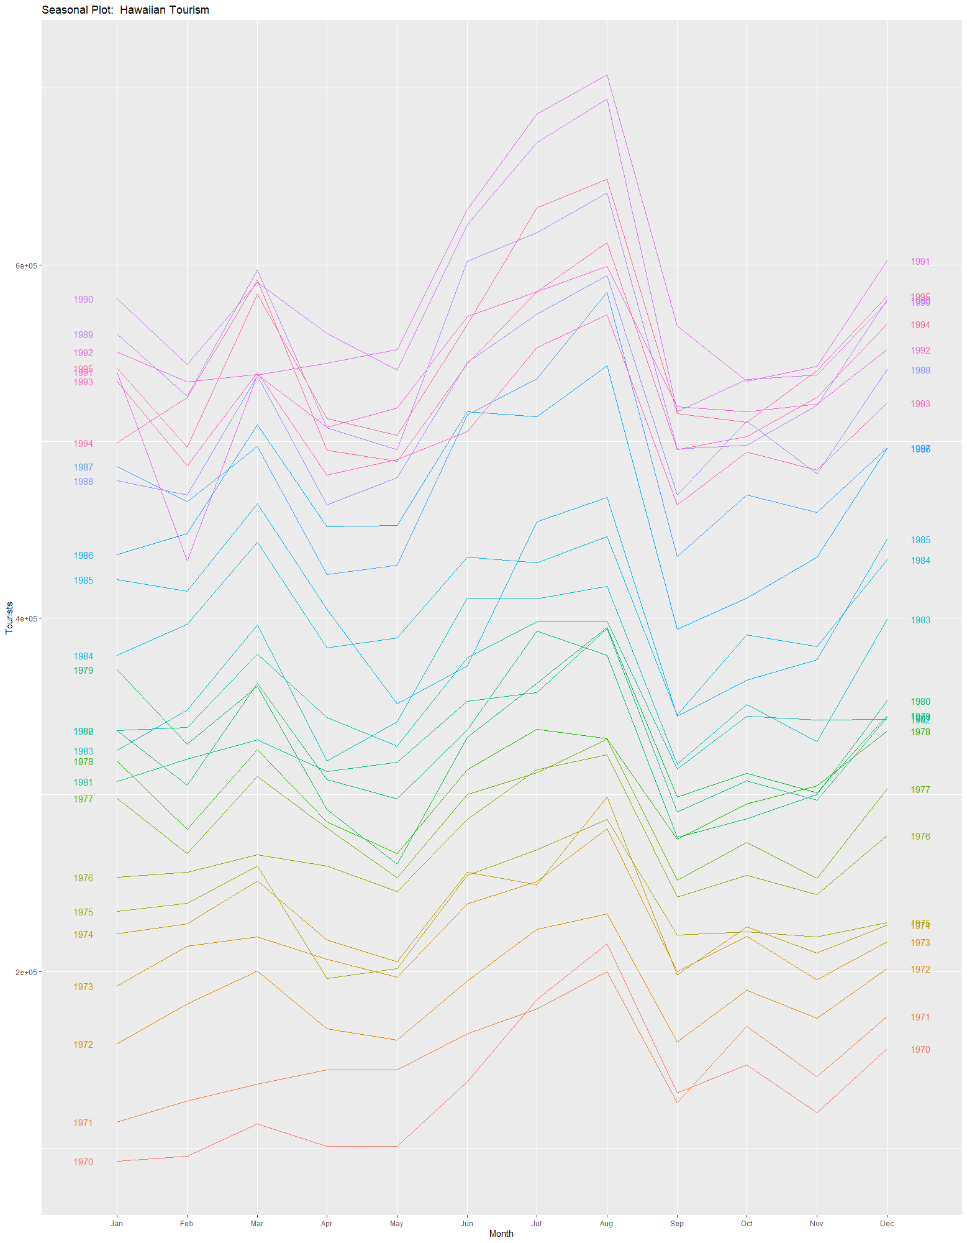

(c) Produce a **Polar Seasonal plot** of the Hawaiian Tourism data. Report it here.

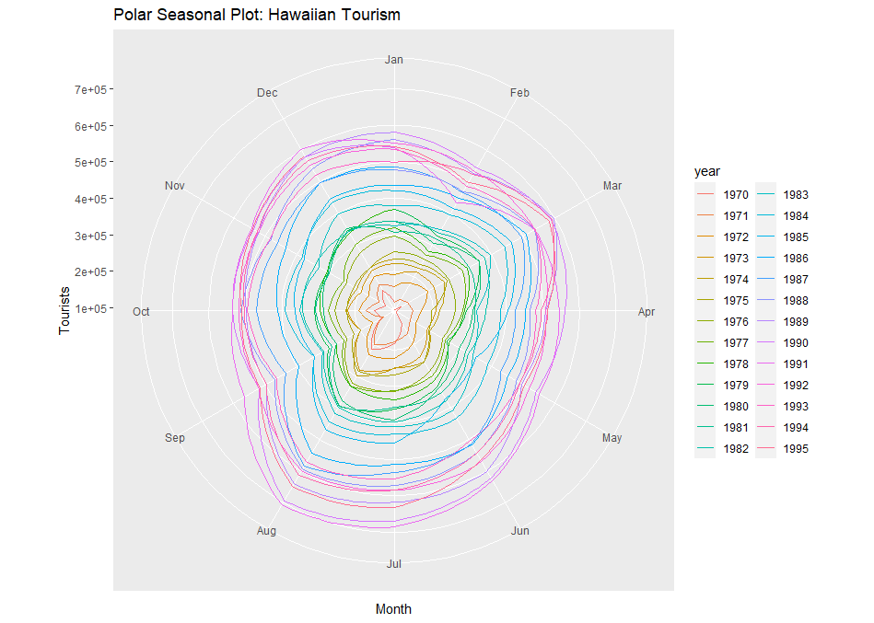

(d) Produce a **Seasonal Subseries plot** month of the Hawaiian Tourism data. Report it

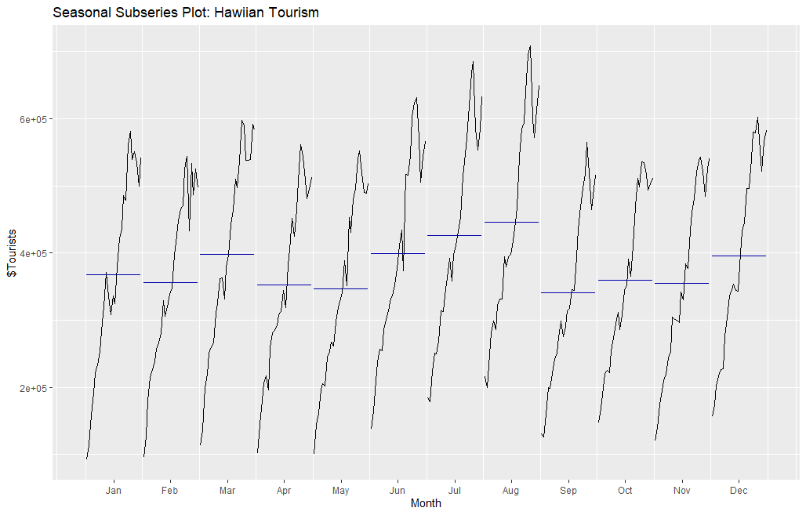

(e) Given the above graphs, state the “strongest” 5 months during the year in Hawaiian tourism. Do these months make sense in being called the strongest months? Explain your reasoning.

The five strongest months are August, July, June, March, and December. It is expected that there would be high amounts of tourism travel during the three summer months (August, July, June), spring break (which occurs in March) and the winter holidays (December).

(f) **Use a block copy to report the R code that you wrote to complete the above tasks.**

library(fpp2)

setwd("C:/Users/madat/Fall 2021/Assignments/Forecasting/Exercise 3")

# Read in the data

hawaii <- ts(scan("Hawaii.csv"),frequency=12,start=c(1970,1))

# Print out the data in hawaii

hawaii

# plot the Hawaii data

ts.plot(hawaii,gpars=list(xlab="year",ylab="tourists", main="Hawaiian Tourism"))

# Buys-Ballot Plot - months-by-year seasonal plot

ggseasonplot(hawaii, year.labels=TRUE, year.labels.left=TRUE) +

ylab("Tourists") +

ggtitle("Seasonal Plot: Hawaiian Tourism")

# Polar Seasonal Plot``

ggseasonplot(hawaii, polar=TRUE) +

ylab("Tourists") +

ggtitle("Polar Seasonal Plot: Hawaiian Tourism")

# Seasonal subseries plot: month-over-years plot

ggsubseriesplot(hawaii) +

ylab("$Tourists") +

ggtitle("Seasonal Subseries Plot: Hawiian Tourism")